**Lesson-2**

**Waves**

Particle - Localization

Wave - nonlocalization

-Disturbance that propagate through space and time

-Energy is transferred

-Little or no permanent displacement of the particles of the medium

Electrons have wave like properties

$$=\frac{h}{p}$$

Sound waves

needs material medium to travel

* Don’t need material medium to travel
* Photons travel

Waves on a string, water waves etc. Here material is displaced ⊥to the direction of travel

Ex.: neutron star or black hole

These are the fluctuation in the curvature of space time which propagates as waves

**Mechanical Wave**

Waves on string (1-D)

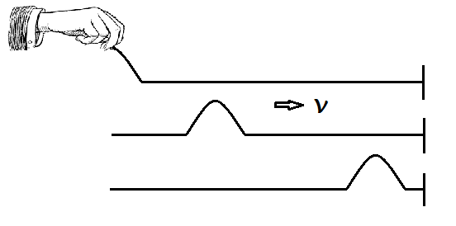

Now the wave (or disturbance) is moving to the right with the speed $v$ (constant)

How to represent this wave?

$$y=f(x,t)$$

where, $y$ is the displacement of the particle from the mean point

***Why $f$ of $x$?***

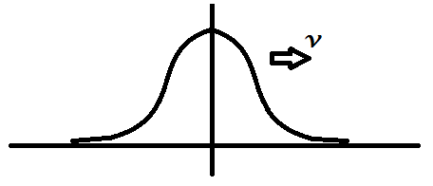Freeze time $t$, i.e. take a photograph at some instant $t$, then the displacement of the particles are a function of $x$. Suppose profile is a bell shaped curve whose equationis $f\left(x\right)=e^{-ax^{2}}$.

***Why $f$ of $t$?***

See one particle, it is changing as a function of $t$ OR the whole profile is travelling with time.

***So Y is a function of two independent variables i.e. $x$*** *& $t$****.***

How to find equation of a travelling wave.

***Fix a frame which is moving with the wave.***

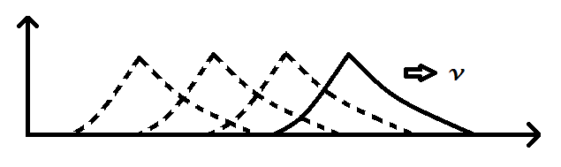

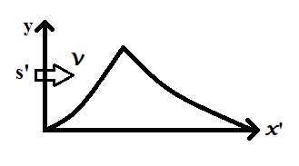

$$y=f(x)$$

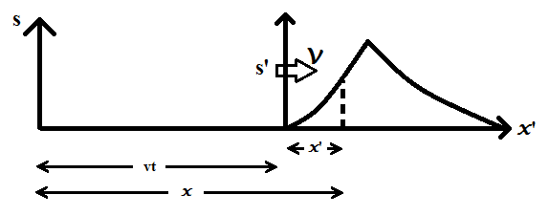

$$y=f(x-vt)$$

c)

$$x^{'}=x-vt$$

Chose a shape function or profile

Replace $x$ by $x-vt$

Eg.

Shape 

$y\left(x,t\right)=e^{-a{(x-vt)}^{2}}$

$$f\left(x±vt\right)=F(t±x/v )$$

So if one end of the rope is manually shaken such that $y=A\sin{ωt}$ then the equation of a wave will be $y=A\sin{(ω\left(t-x/v\right))}$

That means if $f(x)$ is given or $f\left(t\right)$ is given in the first case $t$ is constant where as in the second case $x$ is constant then the equations of the wave can be formulated from these equations by incorporating v of the wave as

$x ⟶x ±vt$

$t ⟶t ± x/v$

**A note about ‘ $v$’**

$$v= ν$$

Here $ν$ is a quantity which is generated by an external agency but λ is the quantity which is coming out from the property of the string that is the tension and μ. So $v$ depends on property of the string $v= \sqrt{\frac{T}{}}$. Now looking at the equation of a wave one can ask a question i.e. this the displacement of a single particle***, how does this equation represents a wave?*** Here we should not forget that this is not for a single particle but for a series of particles through which energy is being transferred. The energy is contained in each of these particles through which energy is being transformed. The energy is contained in each of these particles. The velocity of each of the particle can be calculated by partially differentiating the function that is $\frac{∂y}{∂t}$ (because $y$ is a $(x,t)$).

**One dimension Wave Equation** (this is PDE)

We wish to find next the partial differential equation that is satisfied by all such waves regardless of the particular function $f$. **This is the significance of the PDE.**

$$y=f(x^{'})$$

Where , $x’ = x-vt$

Also,

$\frac{∂x'}{∂x}=1$ And $\frac{∂x'}{∂t}=±v$

Employing chain rule,

$$\frac{∂y}{∂x}= \frac{∂f}{∂x'}∙ \frac{∂x^{'}}{∂x}= \frac{∂f}{∂x}$$

Repeating for second derivatives

$$\frac{{ ∂}^{2}y}{∂x^{2}}= \frac{∂}{∂x}\left(\frac{∂y}{∂x}\right)=\frac{∂}{∂x^{'}}\left({∂y}/{∂x}\right)\frac{∂x^{'}}{∂x}=\frac{∂}{∂x^{'}}\left(\frac{∂f}{∂x'}\right)= \frac{{ ∂}^{2}f}{∂{x'}^{2}}$$

Similarly the temporal derivatives

$$\frac{∂y}{∂t}=\frac{∂f}{∂x'}∙\frac{∂x'}{∂t}=±v \frac{∂f}{∂x'}$$

$$\frac{{ ∂}^{2}y}{∂t^{2}}= \frac{∂}{∂t}\left(\frac{∂y}{∂t}\right)=\frac{∂}{∂x^{'}}\left({∂y}/{∂t}\right)\frac{∂x^{'}}{∂t}=\frac{∂}{∂x^{'}}\left(±v\frac{∂f}{∂x^{'}}\right)(±v)= v^{2}\frac{{ ∂}^{2}f}{∂t^{2}}$$

Combining the results it can be shown that,

$\frac{{ ∂}^{2}y}{∂x^{2}}= \frac{1}{v^{2}}\frac{{ ∂}^{2}y}{∂t^{2}}$

Any wave equation of the term $y=f\left(x±vt\right)$ must satisfy the above equation regardless of the physical nature of the wave itself. Thus to determine whether a given function of $x$ and $t$ represetns a travelling wave, it is sufficient to show either it is of the form $y=f\left(x±vt\right)$ or that it satisfies the above P.D.E .

**Imp Points**

1. There are two equations one is general wave equation and other is particular form of the wave equation. For Example $y_{1}^{}=Ae^{-a{(x-vt)}^{2}}$ and $y_{2}^{}=A\sin{(kx-vt)}$. All the particular equation must satisfy the general wave equation which is a PDE of IInd Order
2. What is the difference between PDE and ODE?

ODE is ordinary differential equation. In differential equation we write some quantity in terms of its rate that how $y$ is changing as a function of $t$ or a function of $x$. Many a times it is very useful to express things in terms of rate. In ODE there is only one independent variable.

In a PDE there are more than one independent variable like in this case $y$ is changing with respect to both $t$ and $x$. So here there are two independent variables viz. $t$ and $x$.

**Particular Solutions**

Harmonic Waves:

1. What are Harmonic waves?

Harmonic waves are one particular solution of General wave equation/ there may be many forms of waves. Harmonic waves are one of them. Harmonic waves involve the sine or cosine functions.

$y={A }_{cos}^{sin}{kx }$ OR $y={A }_{cos}^{sin}{[k(x-vt)]}$

1. Why is it important to study Harmonic Wave?
2. Smooth patterns that repeat themselves endlessly. They are generated by undamped oscillators undergoing SHM.
3. A linear combination of sin and cosine functions can be written to represent any periodic waveform.

Now let us take the equation

$y=A\sin{kx}$ [or $\sin{k(x-vt)}$]

What is the importance of k (Propagation number)? It makes $kx$ dimensionless.

**Harmonic Wave is periodic in both $x$ (space) and (time)**

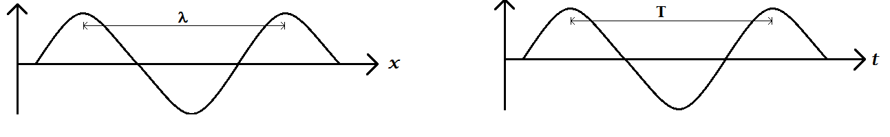

  wavelength

T = time period

$\frac{1}{}= \overline{ν}=$ wave number

$\frac{1}{T}= ν=$ frequency

$=$ No. of waves per unit length

$=$ No of waves per unit time

Because of periodicity λ

Periodicity of T

$y=A\sin{[k\left(x+\right)-vt]}$ $=A\sin{[k\left(x-vt\right)-2π]}$

$k=\frac{2π}{}$ or $= \frac{2π}{k}$

Substitute the value of $k$ thus other forms of the equations are

$$y=A\sin{k(x-vt)}$$

$$y=A\sin\left[2π\left(\frac{x}{}- \frac{t}{T}\right)\right]$$

$y=A\sin\left[kx-ωt\right]$

Argument of sine or

cosine is phase

**Please Note**: Add initial phase angle Φ to all these equations

$$y =A\sin{k\left[x-v\left(t+T\right)\right]}$$

$$=A\sin{[k\left(x-vt\right) +2π]}$$

$$kνt = 2π$$

$\frac{2π}{}∙vt=2π$ or $T= \frac{}{ν}$



$$y = A \sin{(kx-ωt] }$$

OR

$$A\sin{(kx+ωt})$$

is a well-known equation used in many places $k$ makes $kx$ dimesionless and $ω$ makes $ωt$ dimensionless

$$2π× \frac{x}{} + 2π × \frac{t}{T}$$

$x$ and $t$ are two independent variables like two husbands and $k$ and $ω$ are their respective wives they make dimensionless quantity

And also $v = \frac{ω}{k}$

**Velocities in Wave Motion**

1. Particle Velocity $: \frac{∂y}{∂t}$, SHM of the oscillator
2. Wave /Phase velocity: The velocity with which the wave moves. It is also known as Phase velocity(Why?)

$$ϕ=k(x-vt)$$

Now $x$ and $t$ can change such a way that phase remains constant – **Phase** constant means position of the particle

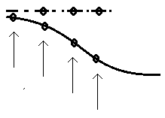 $constant phase$

All the particles in the dotted line are in constant phase. Now how this constant phase moves forward – it means movement of the constant phase with certain velocity and that is the velocity of the wave.

1. Group velocity – It is the velocity of the pulse.

**Harmonic wave as Complex Representation**

$e^{-iθ}=\cos{θ+i\sin{θ}}$ Euler’s formula.

So one can write

$\tilde{y}=e^{-i(kx-wt)}$

So that

$\tilde{y} = Re\left(y\right)= A\cos{(kx-wt)}$ OR $\tilde{y} = Im\left(y\right)= A\sin{(kx-wt)}$

Many mathematical manipulations and operations are easier with exponential functions than with trigonometric equation. Then differential the operation on can take either the real part or imaginary part

**Plane Waves**

1. They are harmonic waves in three dimensions. So simplest example of 3-D waves
2. Concept of Wavefronts–Plane waves have planer wavefronts which extends to infinity, Each generally is perpendicular to the propagation direction

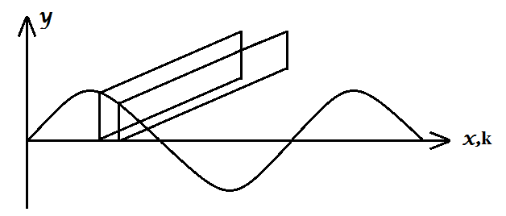 **$wavefronts (constant phase)$**

1. Mathematically

Since it is in any arbitrary direction we write

$$Ψ=A\sin\left(\vec{k}∙\vec{r}-ωt\right)$$

$$\vec{k}= k_{x}i+ k_{y}j + k_{z}k$$

$$r=xi+yj+zk$$

Here **K.r** is constant for every wavefront**.**

**How $\vec{k}∙ \vec{r}$ is a constant?**

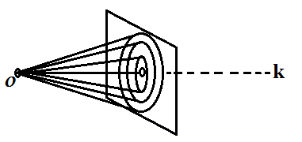**the** projection of $\vec{r_{1}},\vec{r_{2}},\vec{r_{3}}$ along k is const for all ,

If $\vec{r}$ is rotated along $x$.

$$Ψ=A\sin\left(kx-ωt\right)$$

**Spherical waves**

Harmonic wave originating from a point source in a homogenous medium travel at equal rates in all direction.

Wavefronts, surfaces of constant phase are then spherical surfaces centered at the source.

$$Ψ=\left(\frac{A}{r}\right)e^{i\left(\vec{k}∙\vec{r}-ωt\right)}$$

where, $r$ is the radial distance from the point source to a given point on the wavefront.

$k= \frac{2π}{}$ and $ω= \frac{2π}{T}$

**Cylindrical Waves**

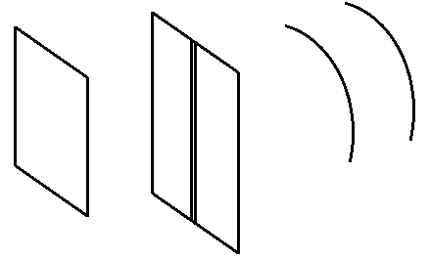

$$Ψ= \frac{x}{\sqrt{ρ}}e^{i\left(kρ - ωt\right)}$$